

PROPUESTA
COMERCIAL


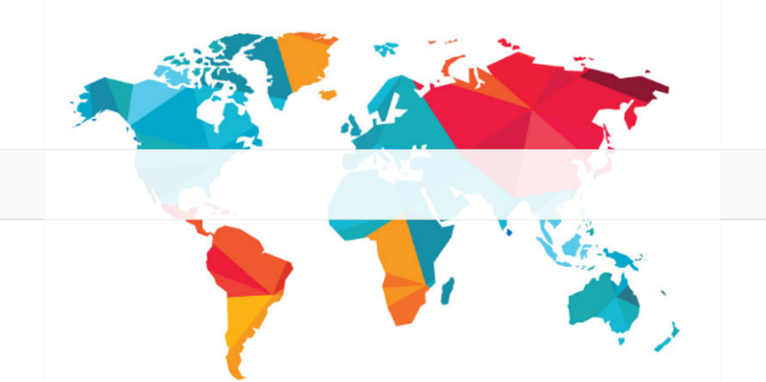

<localización>
localización:
número de oferta:

<O-AA.NNN>

<Título>

título:
fecha:
27/01/2020
cliente:
ÍNDICE
1. INTRODUCTION 2
2. SUPPLY 3
Tank 3
Roof 3
Accesories 3
3. PRICE LIST 4
4. COMMERCIALES TERMS 5
Exclusions 5
Payment method 6
Validity of the Offer 6
Delivery Time 6
Dominio Reserve 6
Warranty 6

INTRODUCTION

The purpose of this document is the economic proposal of:

300 m³ tank with curve cover, made of Polyester Reinforced with Fiberglass (PRFV). This offer includes two transport options: FOB and CIP.

Calculation and structural design according to codes:
- EC 1990 – Basis of structural design
- EC 1991-1 – Part 1-1: General actions
- EC 1991-4 – Part 1-4: Action on structures – General actions – Wind load
- EC 1993-1-1 – Design of Steel structures – Part 1-1: General rules and rules for buildings
- EC 1993-1-5 – Design of Steel structures – Part 1-5: Plated structural elements
- EC 1993-1-6 – Design of Steel structures – Part 1-6: Strength and stability of shell structures
- EC 1993-1-8 – Design of Steel structures – Part 1-8: Design of joints
- AWWA D103-09

SUPPLY
The various equipment subject to this offer shall have the following characteristics:

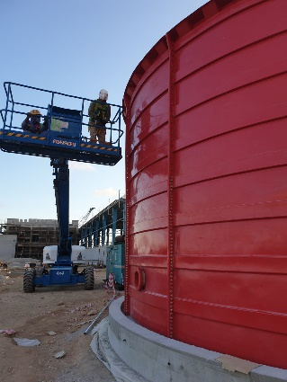
Tank
- Material = PRFV.
- Height = 7,03 m (125 mm embebido).
- Nominal diameter = 7,69 m.
- Base Area = 46,38 m²
- Freeboard = 450 mm.
- Embedded= 125 mm.

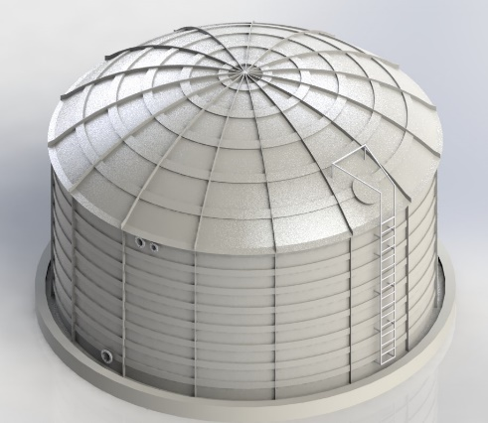
Roof
- Material = PRFV.
- Type = Curve.
- No walkable.
- Ø = 7,69 m.

Accesories
- Vertical ladder with resting platform
- Manhole (ø = 600 mm)
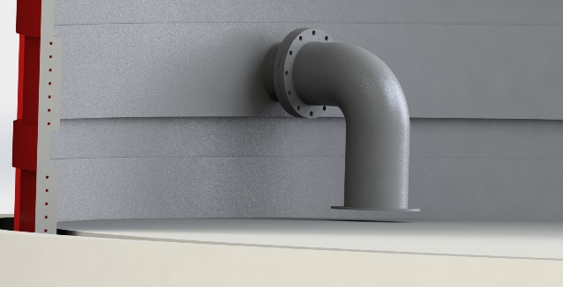
- Hatch

PRICE LIST

Cost description |  | Price (€)
300 m³ Tank |  | 38.028
Flat Roof ø = 7,69 m
Accessories and connections | DN200 Flat Flange EN-1092-1
 | Ladder
 | Manhole
 | Hatch
Installation |  | 8.000
Transport |  | 3.800
Total |  | 59.771

Total Price = 59.771 €

Civil works not included in the price.
This budget does not include valves and instruments.
The price of a supervisor is 650 euros / day. Excluding travel, accommodation and maintenance.
Periodo del proyecto: 9 meses

These prices are net. They do not include taxes.

ARTEIN has no responsibility for the design and execution of civil works, as well as future settlements of land that may occur.

ARTEIN will provide only the characteristics of the foundation detail and slab required to be designed by a local civil engineer or designer.

COMMERCIALES TERMS

Exclusions
- Access to the work must be ensured and easily accessible.
- The area around the foundations should be easily accessible from either side and leveled with the bottom plate at a minimum distance of 2m from the tank.
- The floor must be hard enough to be able to use a mobile platform.
- Foundations must meet our foundation requirements. If officially required, approval of a reinforcement must be made by an impartial design office.
- The foundations must be cured for a minimum of 28 days and have a crack resistance of a minimum of 1.5 N/mm^{2.} The foundation must withstand the loads of our tank.
- The position of 0 º must be marked and fixed for tank adjustment.
- Training/information on all aspects relevant to the customer's facilities must be ensured, as well as training in the peculiar aspects of occupational risk prevention and regulations specific to the client.
- If wind occurs (more than 4 force), durable rain, snow, frost, etc. the assembly must be stopped, which would have a deferred impact on the end date.
- Means of unloading and lifting for assembly (cranes, forklifts, etc..).
- Any masonry, civil works or land movement that results from the installation.
- Fluid rushes to consumption points.
- Electricity to work. Electromotive force required for assembly.
- Fire protection of equipment.
- Start-up products.
- Water filling and leak test to be performed and approved by the customer.
- Potential compensation, grounding and storm protection to be performed by the customer.
- Discharge media and lifting machinery needed.
- Taxes and legalizations.
- Design approval rates.
- Work plans and plans must be signed by the client before construction work began.
- The customer must provide our staff with a suitable premises or department for the storage of parts, equipment and tools, at their expense the insurance of theft or risk of loss of any element deposited in the aforementioned premises.
- It is allowed to work 10 hours a day, including the weekend.
- In general, any supply not expressly specified in this offer.

Payment method
- 50% with the order.
- 50% delivering the material.

Validity of the Offer
This offer is valid for three months.

Delivery Time
90 days from confirmation of design drawings.

Dominio Reserve
The buyer acknowledges to the seller ownership of the materials and works described in this offer until payment of the amount indicated therein, according to the payment terms established.

Warranty
- The warranty of the tanks for manufacture and assembly will be for a period of 12 months against any manufacturing or assembly defect, including this warranty defective parts. Additional periods to be negotiated at the time of the purchase order, having been defined previously.

- The warranty, except in case of hidden defect, covers the replacement in our workshop of defective parts. In case this substitution must be made outside our workshop, the warranty covers only the supply of the spare part being on behalf of the customer the amount of labor for the assembly of the same on our equipment.

- ARTEIN, is not responsible for the consequences of modifications or works carried out by the client or third person, without your prior written authorization.

- The supplier, as a result of the warranty established and comprising exclusively of the above paragraphs, accepts no other liability or claim for damages or breaches, caused directly or indirectly to the buyer.

- "Any provision of the aforementioned may be varied in its context, provided that by mutual agreement both parties, buyer and seller, so stipulate, signing the corresponding explanatory notes for this purpose".


Fdo. <nombre-trabajador> <apellido-trabajador>
<cargo>

